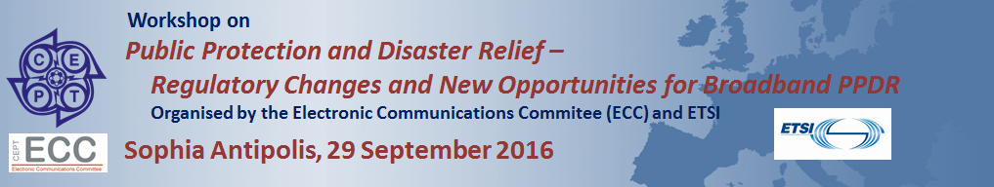
Workshop Programme- 29 September 2016
Time | Presentation Title | Presenter
08:00 | Registration opens
09:00 | Welcome address | Mr Luis Jorge Romero Saro, ETSI Director-General
Session 1 – Setting the Scene
Moderator: Mr Eric Fournier, Chairman of the Electronic Communications Committee (ECC), ANFR France
09:10 | CEPT/ECC-ETSI Co-operation Process and relation to standardisation activities | Mr Thomas Weber, European Communications Office (ECO)
09:25 | Overview of ETSI Activities in relation to PPDR | Ms Chantal Bonardi, ETSI Technical Officer
09:40 | Introduction, CEPT ECC Results on BB-PPDR | Mr Laurent Bodusseau, Chairman of Project Team FM49, ANFR France
10:10 | Questions & Answers
10:25 – 10:55 Coffee & Networking Break
Session 2 – Standardisation Activities
Moderator: Mr Holger Butscheidt, Chairman of ETSI TC ERM/ OCG RED-EMCD, Bundesnetzagentur Germany
10:55 | Work on Harmonised Standards for BB-PPDR | Mr Brian Murgatroyd, Chairman of ETSI TCCE (TETRA and Critical Communications Evolution)
11:15 | 3GPP Activities for BB-PPDR | Mr Yannick Lair, LG Electronics, Chairman of 3GPP SA6
11:35 | Protocol conformance and Interoperability specifications | Mr Anthony Wiles, ETSI Centre for Testing & Interoperability
11:55 | Questions & Answers
12.15- Networking Lunch
Session 3: National Case Studies
Moderator: Mr Thomas Weilacher, Chairman of CEPT ECC/WGFM, Bundesnetzagentur Germany
13:30 | United Kingdom | Mr Ari Toivonen, Home Office of the United Kingdom
13:50 | France | Mr Patrice Juillard, French Ministry of the Interior
14:10 | Nordic Countries (Denmark, Finland, Norway, and Sweden) | Mr Jan Helseth, Norway, Directorate for Emergency Communications
14:30 | Questions & Answers
14:50 Coffee & Networking Break

Session 4 – Future challenges: Work in Progress
Moderator: Mr David Hugh Williams, Chairman of ETSI Special Committee EMTEL (Emergency Telecommunications), Qualcomm
15:20 | Motorola Solutions | Mr Jeppe Jepsen, Director of International Business Relations, Motorola Solutions
15:40 | NOKIA | Mr Jean-Pierre Bonin, Nokia Senior Expert
16:00 | Airbus Defence and Space – SLC  PPDR with new Regulation | Mr Philippe Mège, Airbus Senior Expert
16:20 | Public Safety Communication Europe (PSCE)  Horizon 2020 EU BRoadmap Project for Public Safety Communications | Mr Manfred Blaha, Brigadier-General  Technology Advisor for National Crisis-  and Disaster Prevention Management,  Austrian Federal Ministry of the Interior, and PSCE Member of the Board of Officers
16:40 | Questions & Answers
17:00 - CLOSING REMARKS: Wrap-up
Mr Thomas Weilacher (Chairman of CEPT ECC/WGFM) and Mr Michael Sharpe (ETSI)
17:30 End of Workshop

